For Worldwide Release: May 2013
BRUCE MATHESON JOINS TERRATEC AS REGION MANAGER
Release Number: 13101

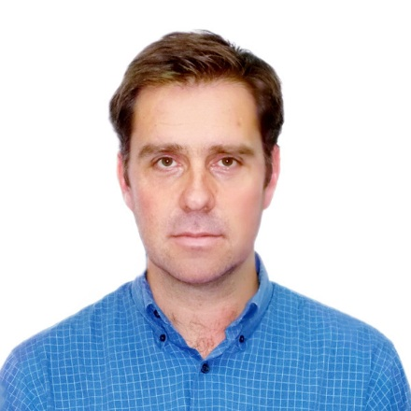
Bruce Matheson has joined Terratec, the Australian TBM and Mining Equipment designer and manufacturer. He will concentrate on developing the expansion of the Company beyond Australasian borders. “I am thrilled about becoming part of the Terratec team” -said Bruce on the phone recently- “It is an amazing time for Terratec right now with at least one machine going out the door every month like the eight TBMs going for Delhi Metro, four delivered so far and all on time”. An exciting aspect of the appointment for Bruce is the increased product line as Terratec is also a world leader in the ever growing Raise Boring Machine (RBM) market.

Terratec has been responsible for the design and fabrication or refurbishment of over 50 TBM’s and RBM’s over the last almost 25 years since incorporation in Australia, where there design centre and one of their main fabrication facilities are located.

More information can be found on the web at www.terratec.com.au or email Bruce bruce.matheson@terratec.com.au

