DMRC starts tunnelling work from INA to South Extension

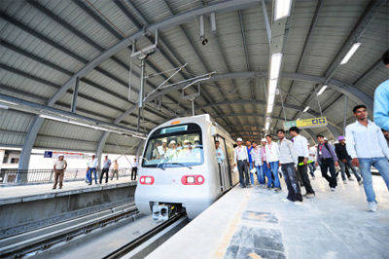

NEW DELHI: Delhi Metro Rail Corporation (DMRC) today started underground tunneling work between INA and South Extension on the Mukundpur-Shiv Vihar corridor as a part of its Phase-III.
The tunnelling work, which would cover a distance of 924 metre, was initiated by lowering the first Tunnel Boring Machine (TBM) at INA.
It will be part of BhikajiCama Place - Lajpat Nagar underground section of the Mukundpur-Shiv Vihar corridor.
The initial drive of this TBM after its full assembling at the site is expected to start in the first week of November.
DMRC will place 6,145 precast rings in a total tunneling drive of 4.299 km between BhikajiCama Place and Lajpat Nagar. The tunnel will have an internal diameter of 5.8 metre and width of 1.4 metre.
The underground stretch between BhikajiCama Place and Lajpat Nagar will witness a total of eight TBM launchings, including two each from INA to South Extension, from South Extension to Lajpat Nagar, from Sarojini Nagar to INA and two more TBM launches from BhikajiCama Place to Sarojini Nagar.
This is the second TBM to be lowered on the 58.467 km long Mukundpur-Shiv Vihar corridor. The first TBM on this section is currently operational between NetajiSubhash Place and Shalimar Bagh.
DMRC is slated to construct 53 km of underground Metro lines as part of its Phase III construction work for which about 34 TBMs are expected to be used.
A total of 74 tunnels will be constructed in this phase. The tunneling work between Central Secretariat and ITO on the 9.37 km long Central Secretariat - Kashmere Gate corridor has been already completed.
In Phase II, 14 TBMs were pressed into service for the construction of 34.89 km of Metro lines across the national capital.

