The New concrete sprayER; Spraymec 5070 VCfrom Normet
Normet introduced its new concrete sprayerSpraymec 5070 VC with Tier 4 Final (Stage IV) engine in the Euro Mining exhibition in Tampere, Finland on 20-21 May.
The Spraymec 5070 VC is designed for medium capacity spraying works and it can be seen as a “little brother” ofSpraymec 8100 VC as it uses the same high performance carrier but comes with somewhat lower capacity spraying featuresas the “big brother”.
New features include the new spraying boom SB307 providing good reach in tunnel profiles up to 7 m. The boom is equipped with self-lubricating slide pieces and roller to minimize wear and tear. All the boom movements are pressure compensated and have proportional functions allowing operator to create smooth and homogeneous tunnel lining structure.
The Spraymec 5070 VC uses Normet’s low pulsation concrete spraying pump (NSP30) with a theoretical concrete output 28 m³/h and FAD 10 m³ / min / 7bar screw –type compressorwhich gives reliable and sufficient air supply for medium capacity spraying works.
The same intuitive nozzleman’s interface is available for the Spraymec 5070 as is standard for theSpraymec 8100. This includes operator being able to carry out all spraying functions from the radio remote control and follow spraying process parameters though a turntable and movable multi-colored display placed on the front of the machine. Service easiness is arranged through open access to all service points.
Highly accurate accelerator dosing system either with mono-type screw pump or optional low-pulsation Normet LPP-D peristaltic pump is synchronized automatically with concrete output
Norsmart control system can log all spraying process and carrier data such as concrete and accelerator volume,dosing percentage, pumping speed, change of process parameters, engine and compressor hours, hydraulic oil system pressure and temperatures etc.The NorSmart system also provides full fault diagnostics.
The recorded data can be delivered to supervisory checks via USB drive or machine data can be sent out to an external server via WLAN and GPRS..
The available engine options for the Spraymecare Tier 3 (Deutz) and Tier 4 Final (Cummins).
The Tier 4 Final technology utilizesSCR (Selective Catalytic Reduction) and DEF/Ad-Blue (Diesel Exhaust Fuel) urea technology for exhaust after treatment.
The new Spraymec5070 VC is available for factory deliveries in Q4 2015.
 | Spraymec 5070 VC | Spraymec 8100 VC
Spraying boom | SB 307 | SB 508 E
- max vertical spraying reach | 8 m | 14 m
- optimum vertical spraying reach | 7 m | 11 m
- max horizontal spraying reach | 16 m | 24 m
- optimum horizontal spraying reach | 10 m | 16 m
Concrete pump | NSP 30 | NSP 40
-Max theoretical output | 28 m3/h | 30 m3/h
- Length/Diameter of concrete cylinder | 600/200 mm | 920/200 mm
Concrete spraying control system | NordoserXE  Electric control  Low pulsation spraying | Nordoser XI  Intelligent control  Ultra-low pulsation spraying
Compressor | FAD 10 m3/min/7bar | FAD 12 m3/min/7bar
-Soft start unit with 400 V | No | Yes
Temperature measurement for ambient, concrete and accelerator temperatures | No | Yes
Engine options | Tier 3 (Deutz)  Tier 4 Final (Cummins) | Tier 3 (Deutz)  Tier 4 Final (Cummins)

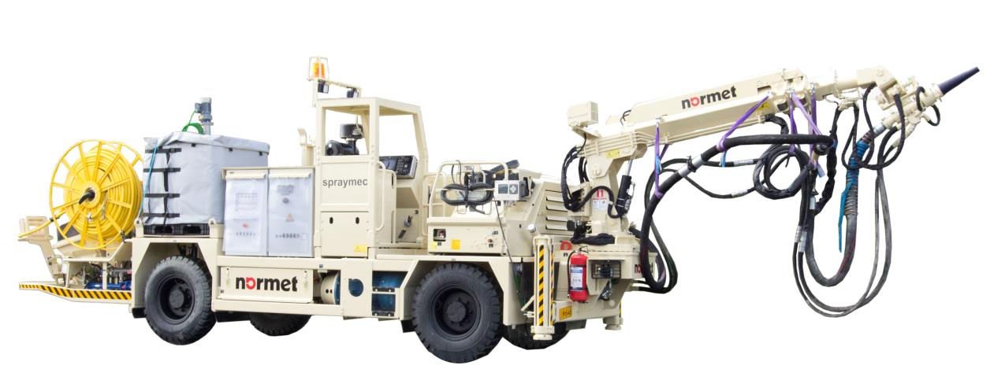
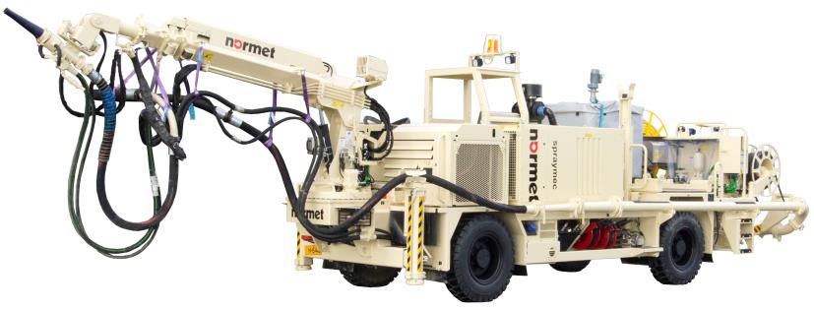
Normet Spraymec 5070 VC

About Normet

About Normet
Normet is a fast growing and innovative technology company with a passion to offer continuous improvement to underground construction and mining processes for increased safety, productivity and profitability.

Normet has a broad underground offering:
• Equipment for concrete spraying and transport, explosives charging, scaling, lifting, installation works, and logistics
• Construction chemicals for sprayed concrete, admixtures for all types concrete, injection systems for rock improvement, reinforcement systems for high deformation conditions, spray applied waterproofing systems and needed chemicals for TBM technology covering hard rock, EPB, open face and slurry type machines
• The new generation energy absorbing rock bolting system; the D-Bolt system specially designed for efficient and reliable rock reinforcement, in both squeezing and burst-prone strata conditions

Normet has delivered over 10,000 built-for-purpose underground machines which are serviced and supported with Life Time Care.

Normet currently employs over 900 business professionals.

Normet is a Finnish based company that operates globally with over 43 locations in 27 countries worldwide.

For further information please contact:

Ilpo Martikainen, Product Line Manager
Phone: + 358 50 544 1332
e-mail: ilpo.martikainen@normet.com

Janne Lehto, Vice President – Equipment Development and Offering
Phone: +358 40 5190525
e-mail:janne.lehto@normet.com

Jukka Pihlava, Marketing Manager
Phone: +41 79 287 46 75
e-mail: jukka.pihlava@normet.com

