CREG won a new Ф15.8m slurry TBM contract
4th sept. 2017
General
On 29th August, CREG has been awarded a new contract for the supply of a Ф15.8m slurry TBM. This TBM will be applied for Chunfeng tunnel Project in Shenzhen and it will be the biggest slurry TBM ever made before by CREG.
Tunnel section sketch
Chunfeng Project is one the most important municipal project for the purpose of easing the traffic congestion in Shenzhen megalopolis. The total tunnel length is more than 5000m, in which 3583m will be built by TBM. Tunnel will cross beneath Metro Line 9, Jibu River (ca. 50m width) and several high risky buildings etc. The settlement control will be a big challenge for the new machine.
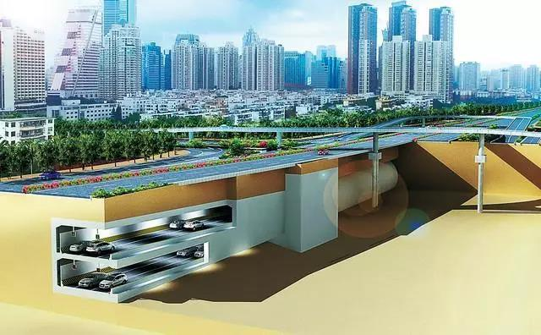
TBM characters
- Boring diameter: 15800 mm
- Max. working pressure: 8 Bar
- Drive power: 6300 kW (350kW*18)
- Nominal torque: 51130 kN∙m
- Max. torque: 69027 kN∙m
- Rotation speed: 0-2,25 rpm
- Thrust force: 24630 t
- Max. advance speed: 50 mm/min
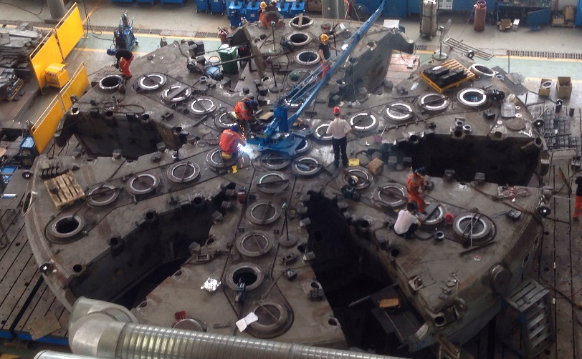
Reference
Another Ф 15.03 slurry TBM is under final assembling in Zhengzhou main factory

